# Effect Size Calculation Software Manual

# (Version 1.0)

# 

# Hangzhou Normal University

# 2014.8

# Introduction

In statistics, an effect size is a quantitative measure of the strength of a phenomenon. Effect sizes are calculated from the data of a study and a wide variety of different effect size measures exist because of different kinds of data and differing study methodologies and to quantify different aspects of research data. Effect sizes are practically important in their own right and play an important role in complementing statistical hypothesis testing, in statistical power analyses, and in meta-analyses where effect sizes across several studies are summarized.

In statistical inference and hypothesis testing, we are always interested in if the treatment effect is significant or not. However, when the sample size is large, p value can be significant though the treatment effect is small.

Reporting effect sizes is considered good practice when presenting empirical research findings in many fields. The reporting of effect sizes facilitates the interpretation of the substantive, as opposed to the statistical, significance of a research result. Effect sizes are particularly prominent in social and medical research. Relative and absolute measures of effect size convey different information, and can be used complementarily.

In nowadays studies, researchers often report the statistical significance, and neglect the report of effect size. To calculate the effect size of brain imaging data, we developed this software on the platform of MATLAB.

# Software manual

## Setup

Unzip the package effect_size.zip, and then put the folder in optional position. Open Matlab, and click **File**→**Set Path** (Fig 1), then click **Add with Subfolders** (Fig 2), and select the unzipped folder last step. After selection, click **Save**→**Close** to close the dialog box.



Fig 1

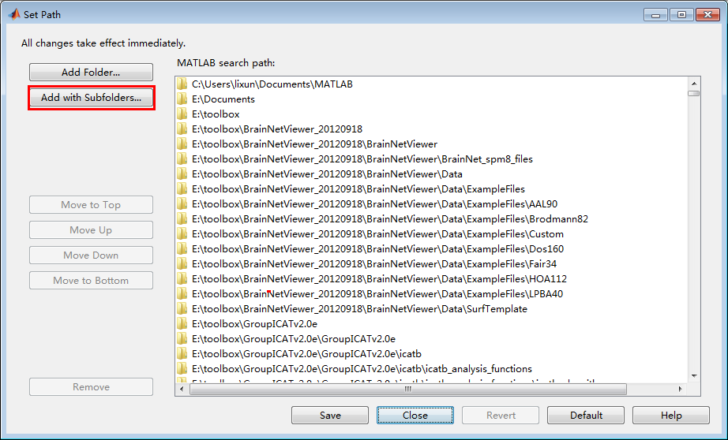

Fig 2

## Operation

**2.2.1 Start the software**

Input **es** in Matlab command window, to open the software interface (Fig 3). For two independent samples, select **Two independent samples** button; for two paired samples, select **Paired samples** button.

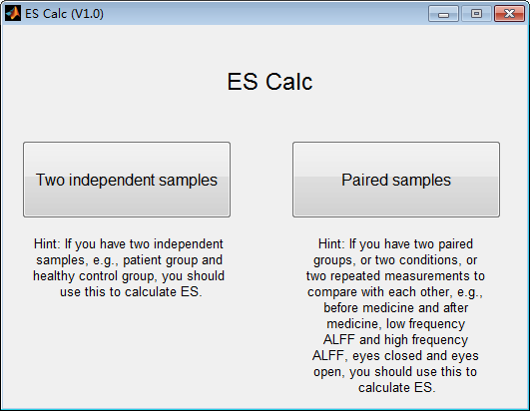

Fig 3

**2.2.2 Add data**

For two independent samples, another interface will show up after selection (Fig 4). Click **Add Group Images** to select folder of the first data group. After selection, click **Add Group Images** again to select folder of the second data group. Attention: the data must be the form of .nii or .img/.hdr.

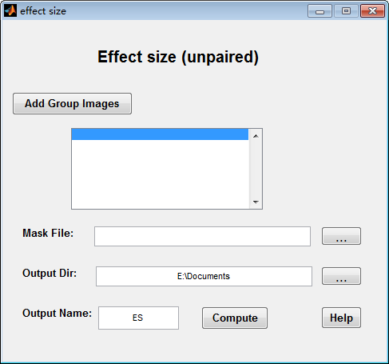

Fig 4

Take the data in ~\effect_size\example_data as the example (Fig 5).

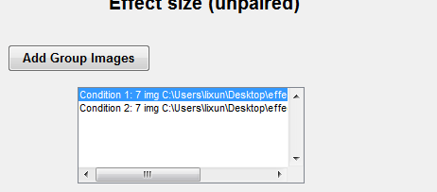

Fig 5

**2.2.3 Add mask**

Click the button at the right of Mask File to choose the mask file that corresponding to the data(Fig 6). Conventional masks all stored in ~\effect_size\functions\mask. The mask file that corresponds to example data is BrainMask_05_61x73x61.img.



Fig 6

**2.2.4 Select output directory**

Click the button at the right of Output Dir to choose the directory to store the results (Fig 7).



Fig 7

**2.2.5 Input the file name of results**

Click the button at the right of Output Name to input the prefix of file name, here entered ES as example (Fig 8).



Fig 8

**2.2.6 Run**

Click the **Compute** Button at the end of software interface. The running information will show up in the command window (Fig 9). The calculation will finish when **Calculation finished** information shows up.

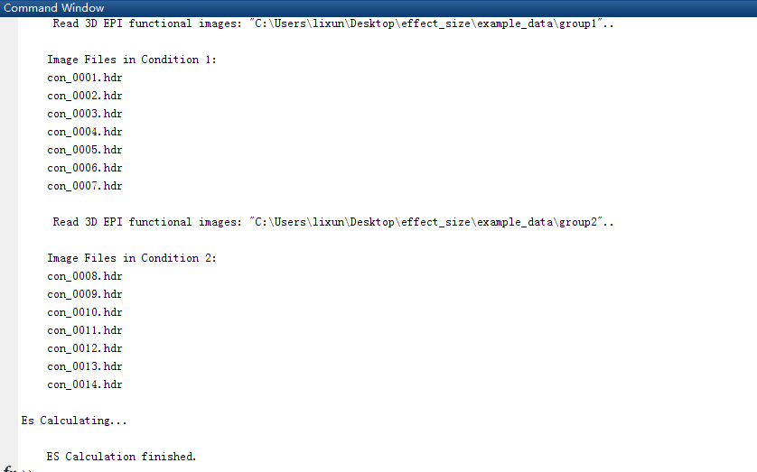

Fig 9

For paried samples, the operation is the same with two independent samples.

## Results

Under the output directory there will be two files, take the file name of ES as the example, they are ES.nii and Larege_ES.nii. ES.nii is the result of effct size for all the voxels in the brain. ES_Large.nii is the result of effect size lager than 0.8, and the values of the voxels with effect size smaller than 0.8 will be zero.

The files can be opened by REST (which can be downloaded from <http://restfmri.net>), and the results are shown below (Fig 10 and Fig 11).

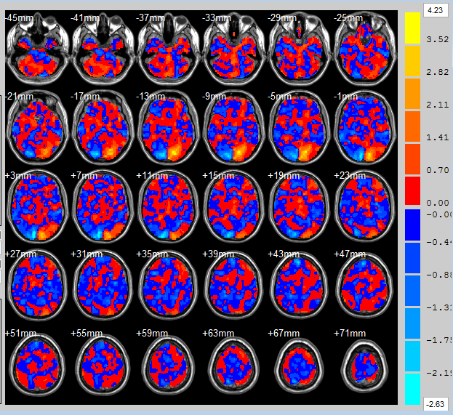

Fig 10 ES.nii

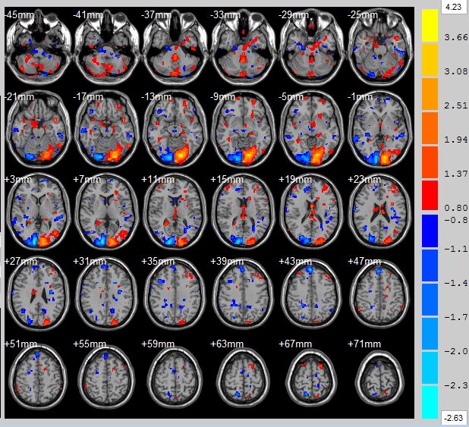

Fig 11 Large_ES.nii

# Appendix

## Download

This software can be downloaded from forum of resting-state fMRI (http://restfmri.net)

## Developers

Gao Zhong-Zhan (gaozhongzhan@126.com)

Li Xun (lixun2011@126.com)

Zhang Han (napoleon1982@gmail.com)

Zang Yu-Feng (zangyf@gmail.com)

## Reference

[1] Jacob Cohen (1988). Statistical Power Analysis for the Behavioral Sciences (second ed.). Lawrence Erlbaum Associates.

[2] Larry V. Hedges (1981). "Distribution theory for Glass's estimator of effect size and related estimators". Journal of Educational Statistics 6 (2): 107–128. doi:10.3102/10769986006002107.