**Dynaimic Time-frame Decomposition Analysis**

# (Version 1.0)

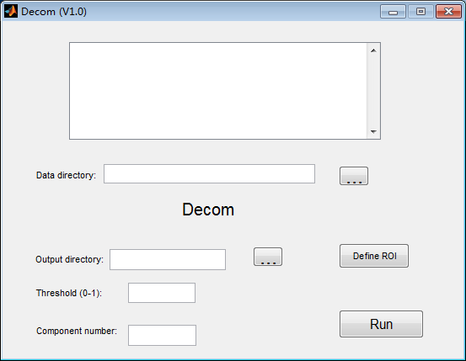

# Hangzhou Normal University

# 2014.8

1. **Introduction**

Many studies have proved our brain to be an intricate system. Understanding the spatial and temporal organization of this complex system is of great importance for both basic and clinical neuroscience.

Nowadays, researchers begin to focus on the dynamic character of brain functional networks or dynamic functional connectivity and dedicated analyzing methods have been proposed, including time-frequency coherence analysis, variable parameter regression, sliding window correlation analysis and temporal decomposition.

Among these methods, the temporal decomposition method can directly cluster time frames into different groups depending on their spatial similarity of the original BOLD signals. Different modes could be decomposed from the original fMRI data, with one brain region shared among them, and other mode-specific regions co-activated at different time frames.

To apply and improve this method, we developed this software on the platform of MATLAB.

1. **Software manual**

**2.1 Setup**

Unzip the package Decom.zip, and then put the folder in optional position. Open Matlab, and click **File**→**Set Path** (Fig 1), then click **Add with Subfolders** (Fig 2), and select the unzipped folder last step. After selection, click **Save**→**Close** to close the dialog box.



Fig 1

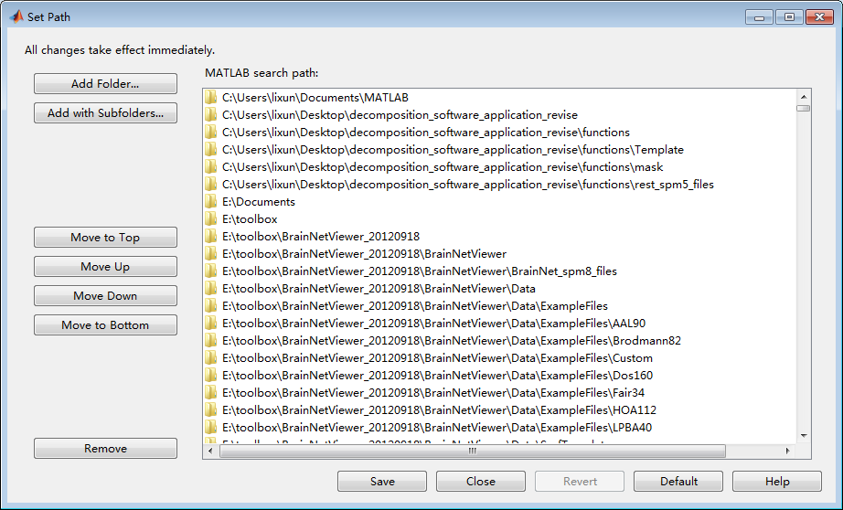

Fig 2

**2.2 Operation**

**2.2.1 Start the software**

Input **Decom** in Matlab command window, to open the software interface (Fig 3).



Fig 3

**2.2.2 Add data**

Click right button on the blank area at the top of the interface, and choose **Add recursively all sub-folders of a directory** (Fig 4). Choose the directory of data, and the different subjects (states) data should be arranged in different subfolders (Fig 5). Attention: the data must be the form of 3D .nii. The background will turn to green when adding data, and it will turn back to blank after all the data are added.

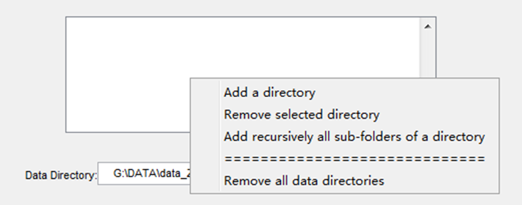

Fig 4

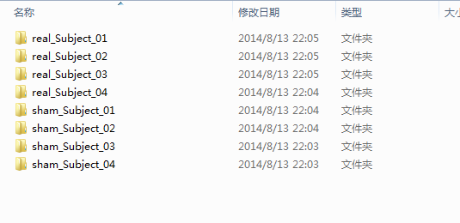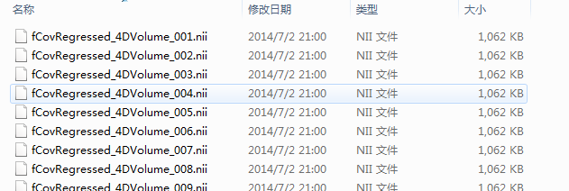

Fig 5

**2.2.3 Define region of interested (ROI)**

Click the **Define ROI** button, and select **Add ROI** (Fig 6). This software provide three ways to define ROI, s**pherical ROI**, **predefined ROI** and **time courses** (Fig 7). Take the spherical ROI as the example, select **spherical ROI** and click **Next**, then input the coordinate of ROI in X, Y and Z, and input the radius of the sphere (Fig 8). Click **OK**→**Done**→**Done**, and return to the main interface.

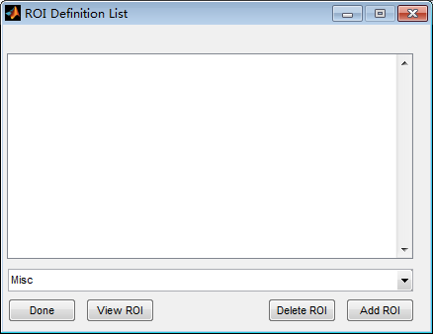

Fig 6

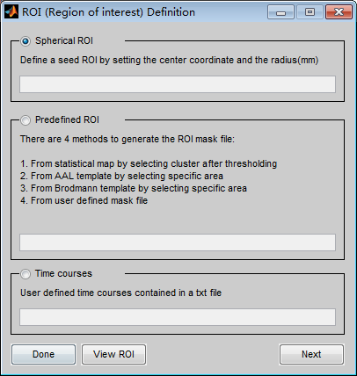

Fig 7

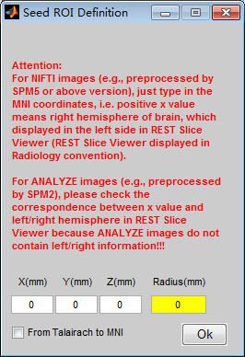

Fig 8

**2.2.4 Set parameters**

Click the button at the right of **Output Directory**, and select the directory to store the results. Input the threshold of time frames in the textbox at the right of **threshold**, and the range should from 0 to 1. Input the component number in the textbox at the right of **component number**, and the number must be an integer (Fig 9).

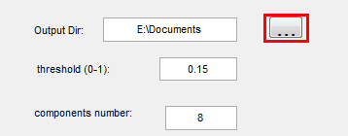

Fig 9

**2.2.5 Run**

Click the Run Button on software interface (Fig 10). The calculation will finish when **All done. Congratulations!** appears in command window.

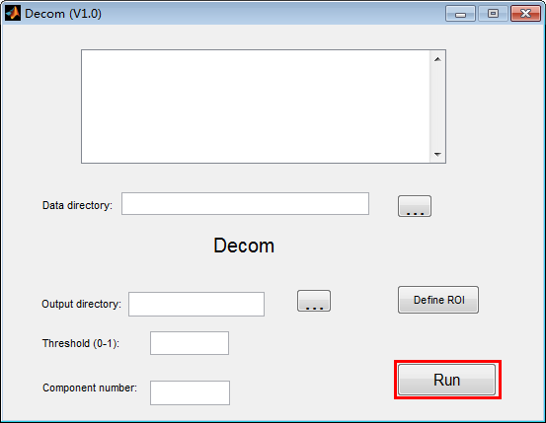

Fig 10

**2.3 Results**

**2.3.1 Content of the results**

The content of the results at the output directory are shown in below (Fig 11). The folders begin with “select” include data that satisfy the threshold. All these data are stored in the folder of “select_all”. The folders with the name of number include the data that belong to the same cluster.

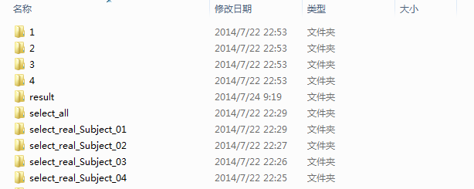

Fig 11

**2.3.2 Content of the results in folder “results”**

The content of the results in the folder “results” are shown below (Fig 12). The files begin with mean represent the average data of different clusters. Mean_all.nii represents the average of all the data that beyond the threshold. Result.txt stores the ratio of time frames of different clusters and with-in cluster intensity (Fig 13). Result2 stores cluster information of every time frame, and the store form includes result2.mat, result2.txt and result2.tif. Result3 stores the ratio of every cluster of every subject (state), and the store form includes result3.mat, result3.txt and result3.tif.

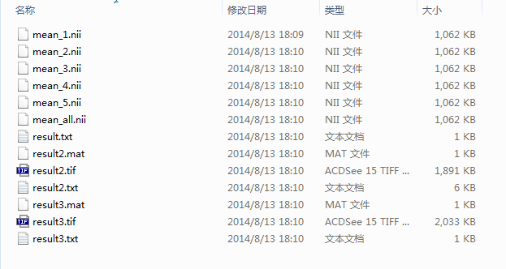

Fig 12

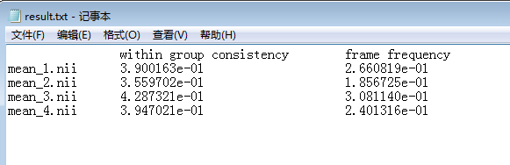

Fig 13

**2.3.3 Check the results**

The mean 3D .nii files can be opened by REST (which can be downloaded from <http://restfmri.net>), and the results are shown below (Fig 14).

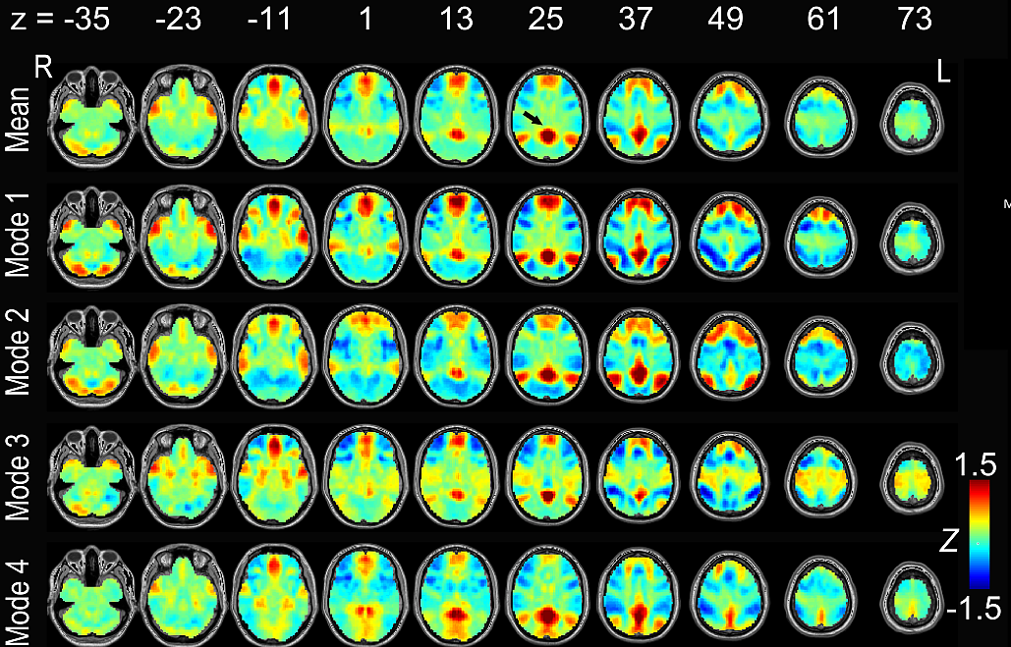

Fig 14

result2: cluster information of every time frame

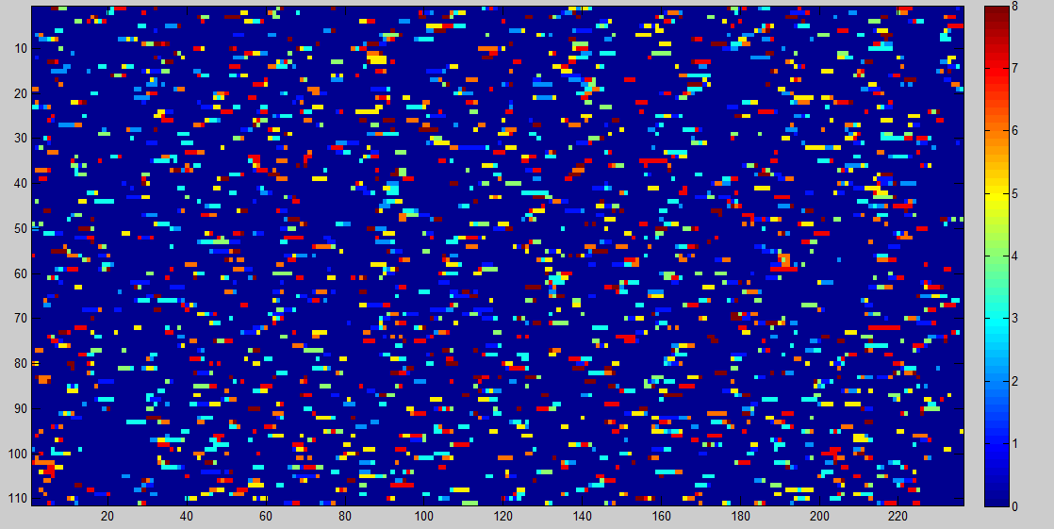

Fig 15

Abscissa represents time points, ordinate represents different subjects (states) and the color represents the ratio.

result3: the ratio of every cluster of every subject (state)

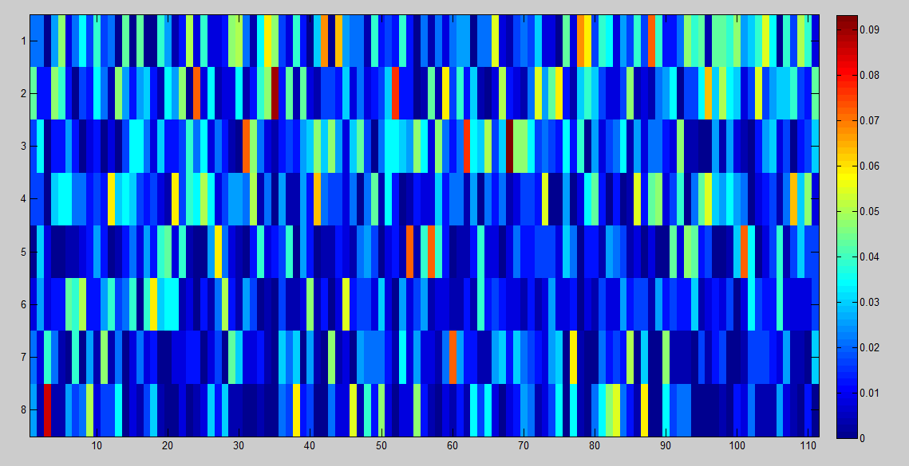

Fig 16

Abscissa represents different subjects (states), ordinate represents different clusters and the color represents the ratio.

1. **Appendix**

**3.1 Download**

This software can be downloaded from forum of resting-state fMRI (http://restfmri.net)

**3.2 Developers**

Li Xun (lixun2011@126.com)

Zhang Han (napoleon1982@gmail.com)

**3.3 Reference**

Liu X, Duyn J H. Time-varying functional network information extracted from brief instances of spontaneous brain activity. Proceedings of the National Academy of Sciences, 2013, 110(11): 4392-4397.