By checking the origin of Harvard-oxford atlas and the fMRI image, I try to match them.

1. The origin of Harvard-oxford atlas

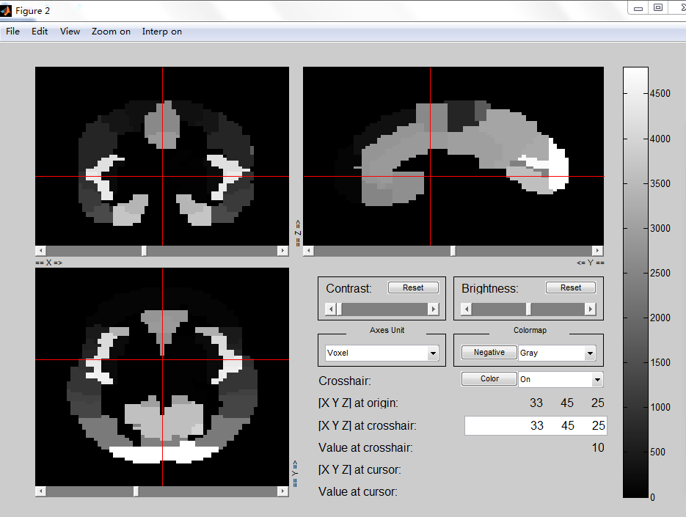

Fig.1 The origin of Harvard-oxford atlas in terms that the Axes Unit is “Voxel”. The [X Y Z] at origin is (33 45 25).

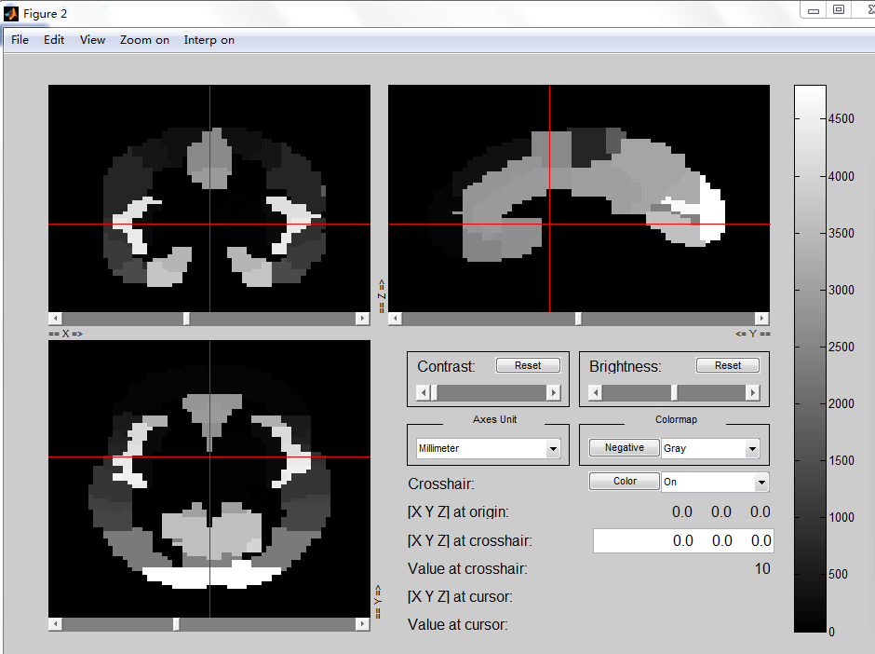

Fig.2 The origin of Harvard-oxford atlas in terms that the Axes Unit is “Millimeter”. The [X Y Z] at origin is (0 0 0).

Therefore, for the Harvard-oxford atlas, the origin (33 45 25) corresponding to the Axes Unit of “Voxel” is (0 0 0) corresponding to the Axes Unit of “Millimeter”.

1. The origin of preprocessed functional image (KKI_0050772_func_preproc.nii)

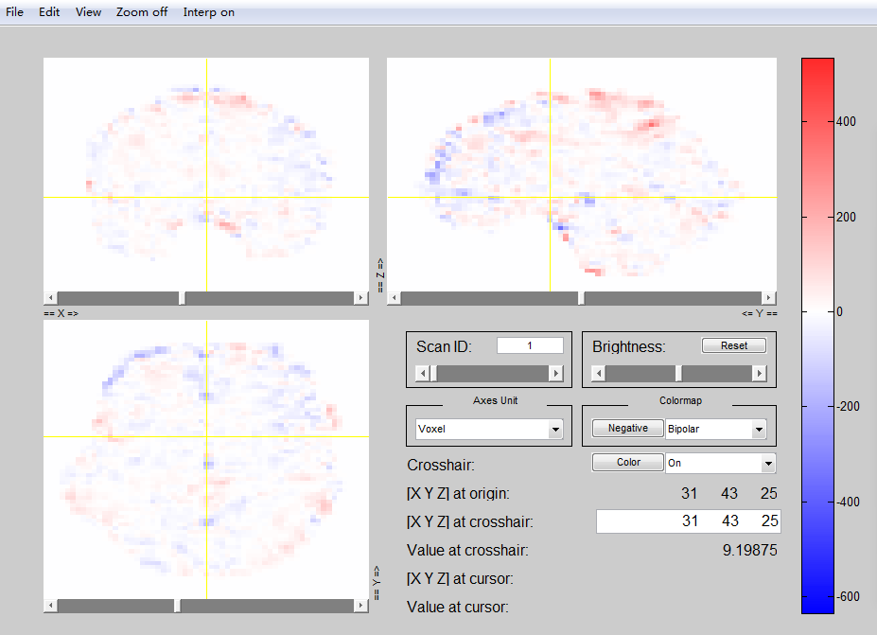

Fig.3 The origin of preprocessed functional image in terms that the Axes Unit is “Voxel”. The [X Y Z] at origin is (31 43 25).

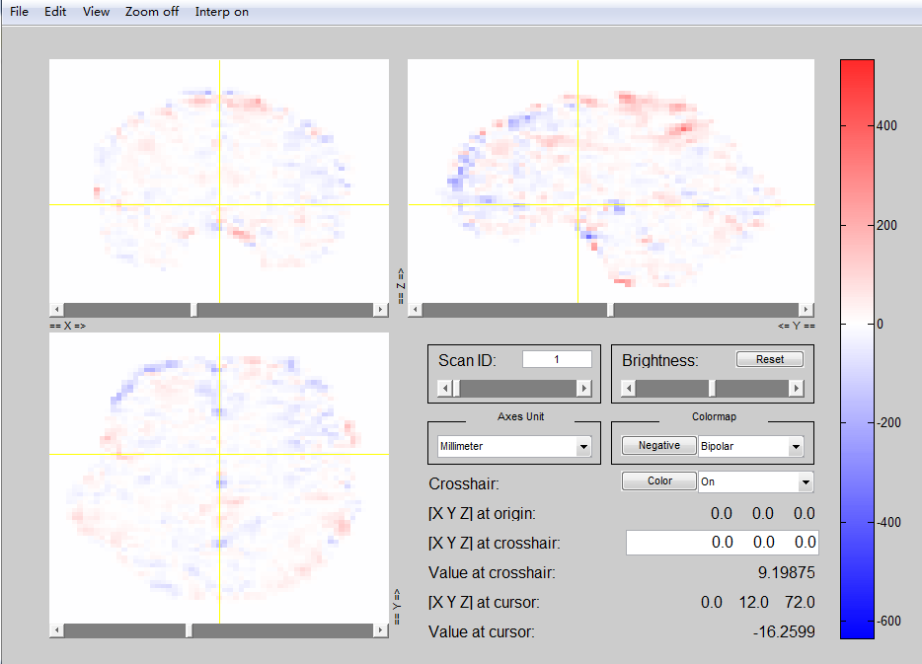

Fig.4 The origin of the preprocessed functional image in terms that the Axes Unit is “Millimeter”. The [X Y Z] at origin is (0 0 0).

Therefore, for the preprocessed functional image, the origin (31 43 25) corresponding to the Axes Unit of “Voxel” is (0 0 0) corresponding to the Axes Unit of “Millimeter”.

Therefore, since the shape of the atlas is 65x77x63 and the shape of the functional image is 61x73x61, I need to remove 4 planes from the first dimension, 4 planes from the second dimension, and 2 planes from the 3rd dimension. In addition, because the origin of the Harvard-oxford atlas is (33 45 25), and the origin of the functional image is (31 43 25), I think I need to remove the first 2 and last 2 planes from the first dimension, remove first 2 and last 2 planes from the second dimension, and remove last 2 planes from the third dimension **(I also tried to the first 1 and last 1 planes from the third dimension)**.

Based the above assumption, I wrote the program namely “Compare_TC.m”, in order to compare (1) the Harvard Oxford atlas time courses directly downloaded from the FCP-INDI bucket and (2) time courses calculated from the processed fMRI data downloaded from the FCP-INDI bucket.

If the assumption is true, the two kinds of time courses should be same. However, the two kinds of time courses are not same. The time series for ROI 22 are shown as follows. The red curve is from the (1) the Harvard Oxford atlas time courses directly downloaded from the FCP-INDI bucket. The blue curve is from (2) time courses calculated from the processed fMRI data downloaded from the FCP-INDI bucket.

